-On Boarding :

select name from people

SELECT 'SQL'

AS result;

-selecting single column :

select title

from films;

select release_year

from films;

select name

from people;

-selecting multiple column

select title

from films

SELECT title, release_year

FROM films;

SELECT title, release_year, country

FROM films;

SELECT *

FROM films;

-Select Distinct : find unique value

select distinct country

from films;

select distinct certification

from films

select distinct role

from roles

-Select count : count number of rows of table

select COUNT(*)

from reviews;

-practice with count :

-Count the number of (non-missing) birth dates in the people table

SELECT COUNT(birthdate)

FROM people;

-Count the number of unique birth dates in the people table.

SELECT COUNT(distinct birthdate)

FROM people;

**#FILTERING ROWS**

-filtering result

For example, you can filter text records such as title. The following code returns all films with the title 'Metropolis':

**SELECT title**

**FROM films**

**WHERE title = 'Metropolis';**

Notice that the WHERE clause always comes after the FROM statement!

-simple filtering for numeric values :

#Get all details for all films released in 2016.

select *

from films

where release_year =2016

#Get the number of films released before 2000

select count(*)

from films

where release_year < 2000

#Get the title and release year of films released after 2000

select title, release_year

from films

where release_year > 2000

-Simple filtering of text :

#Get all details for all French language films

select *

from films

where language = 'French'

#Get the name and birth date of the person born on November 11th, 1974. Remember to use ISO date format ('1974-11-11')!

select name, birthdate

from people

where birthdate = '1974-11-11'

#Get the number of Hindi language films.

select count(*)

from films

where language = 'Hindi'

#Get all details for all films with an R certification

select *

from films

where certification = 'R'

-Where And :

#Get the title and release year for all Spanish language films released before 2000

select title, release_year

from films

where language ='Spanish' and release_year <2000

#Get all details for Spanish language films released after 2000

select *

from films

where language = 'Spanish' and release_year > 2000

#Get all details for Spanish language films released after 2000, but before 2010

select *

from films

where language = 'Spanish' and release_year > 2000 and release_year < 2010

-Where and OR

When combining AND and OR, be sure to enclose the individual clauses in parentheses, like so:

**SELECT title**

**FROM films**

**WHERE (release_year = 1994 OR release_year = 1995)**

**AND (certification = 'PG' OR certification = 'R');**

**-**get the title and release year of films released in the 90s which were in French or Spanish and which took in more than $2M gross :

SELECT *

from films

where (release_year >= 1990 and release_year < 2000) AND

(language = 'French' or language ='Spanish') AND

(gross > 2000000)

-Between : Filter Values in specific range

**SELECT title**

**FROM films**

**WHERE release_year**

**BETWEEN 1994 AND 2000;**

#get the title and release year of all Spanish language films released between 1990 and 2000 (inclusive) with budgets over $100 million

select title, release_year

from films

where (release_year between 1990 and 2000) and

(budget > 100000000) and

(language = 'Spanish' or language = 'French')

-Where In : the function is like OR operator

**SELECT name**

**FROM kids**

**WHERE age IN (2, 4, 6, 8, 10);**

**#**Get the title and release year of all films released in 1990 or 2000 that were longer than two hours. Remember, duration is in minutes

select title, release_year

from films

where release_year IN (1990, 2000) and duration >120

**#**Get the title and language of all films which were in English, Spanish, or French

select title, language

from films

where language in ('English', 'Spanish', 'French')

**#**Get the title and certification of all films with an NC-17 or R certification

select title, certification

from films

where certification in ('NC-17', 'R')

-Introduction to Null and is Null

-to count the number of missing birth dates :

**\*SELECT COUNT (*)**

**\*FROM people**

**\*WHERE birthdate IS NULL**

**-select name of people whose birth dates are not null :**

**\*SELECT name**

**\*FROM people**

**\*WHERE birthdate IS NOT NULL;**

-Get the people name where still alive :

select name

from people

where deathdate is null

-Get the title of film which doesn’t have budget :

select title

from films

where budget is null

-Get the number of film where doesn’t have language :

select count (*)

from films

where language is null

-LIKE AND NOT LIKE :

*select name

*from companies

*where name like ‘DataC_mp’;

-Get the name of people whose names begin with ‘B’

select name

from people

where name like 'B%'

-Get the name of people whose names have r as the second later

select name

from people

where name LIKE '_r%'

-Get the name of people whose names don’t start with A

select name

from people

where name NOT LIKE 'A%'

-Aggregate Function

**\*select avg (budget)**

**\*from films;**

-Combining aggregate functions with where

**\*select sum (budget)**

**\*from films**

**\*where release_year >= 2020**

-A Note on arithmetic

**-if the integer divided by integer will be result to integer. For example 4/3 will be back to 1**

**-if want more specific result, use comma in the back. For example 4.0/3.0 will be back to 1.3**

-it’s as simple as aliasing

*select max(budget) as max_budget

max(duration) as max_duration

*from films;

-get the title and net_profit :

select title, gross - budget AS net_profit

from films

-get the title and duration hours from films :

select title, duration/60.0 as duration_hours

from films

-get average duration in hours

select avg (duration)/60.0 as avg_duration_hours

from films

-Even more aliasing

-get percentage of dead

-- get the count(deathdate) and multiply by 100.0

-- then divide by count(*)

select count (deathdate) * 100.0 / count (*) as percentage_dead

from people

-get the number of years between first and last films

select max (release_year) - min (release_year) as difference

from films

-get the number between first and last film in decade :

select (max (release_year) - min (release_year))/10.0 as number_of_decades

from films

-Order by

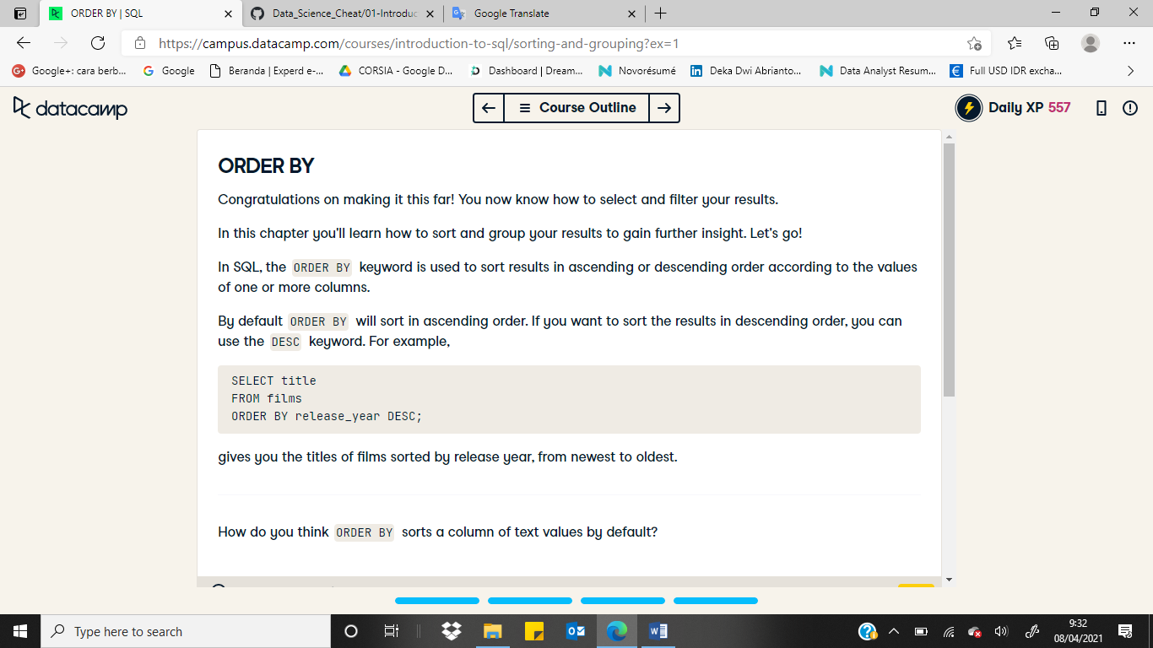

-Sorting Single Column

-sorted by name

select name

from people

order by name

-sorted by birthdate

select name

from people

order by birthdate

-get the name and birthdate, and sorted it by birthdate

select birthdate, name

from people

order by birthdate

-Sorting single column(2)

*Get the title of films released in 2000 or 2012, in the order they were released.

select title

from films

where release_year in (2000, 2012)

order by release_year

*Get all details for all films except those released in 2015 and order them by duration.

select *

from films

where release_year <> 2015

order by duration

*Get the title and gross earnings for movies which begin with the letter 'M' and order the results alphabetically.

select title, gross

from films

where title like 'M%'

order by title

-Sorting single column descending

*Get the IMDB score and film ID for every film from the reviews table, sorted from highest to lowest score.

select imdb_score, film_id

from reviews

order by imdb_score desc

*Get the title for every film, in reverse order.

select title

from films

order by title desc

*Get the title and duration for every film, in order of longest duration to shortest.

select title, duration

from films

order by duration desc

-Sorting Multiple columns

Contoh :

**SELECT birthdate, name**

**FROM people**

**ORDER BY birthdate, name;**

*Get the birth date and name of people in the people table, in order of when they were born and alphabetically by name.

select name, birthdate

from people

order by birthdate, name

*Get the release year, duration, and title of films ordered by their release year and duration.

select release_year, duration, title

from films

order by release_year, duration

*Get certifications, release years, and titles of films ordered by certification (alphabetically) and release year.

select certification, release_year, title

from films

order by certification, release_year

*Get the names and birthdates of people ordered by name and birth date.

select name, birthdate

from people

order by name, birthdate